Title: Design and develop custom Application (Mini Project) using Salesforce Cloud.

Step-1: Click on Lightning Experience

Step-2: Click on Setup and select Setup for current App.

Step-3:
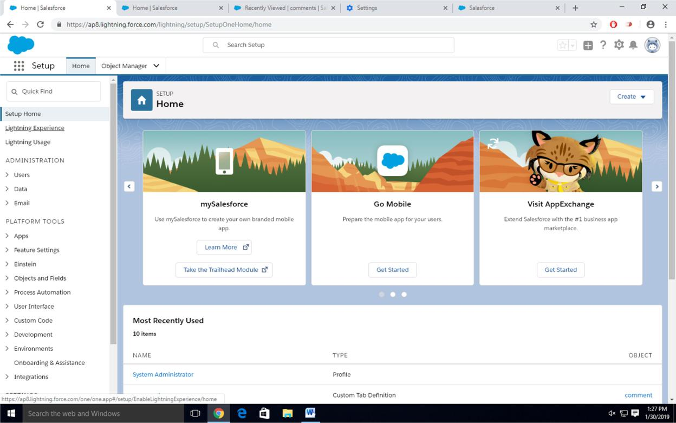

Click on Create an Object

So Click on Object Manager Tab next to Home Tab

Click on Create –Custom Object
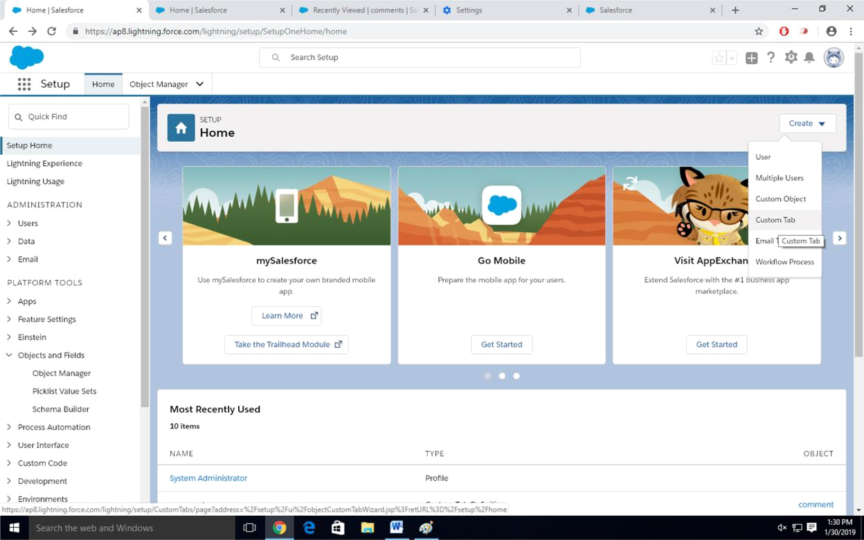

Step-4 New custom object page Open

Label as a-Comment

Plural label- comments
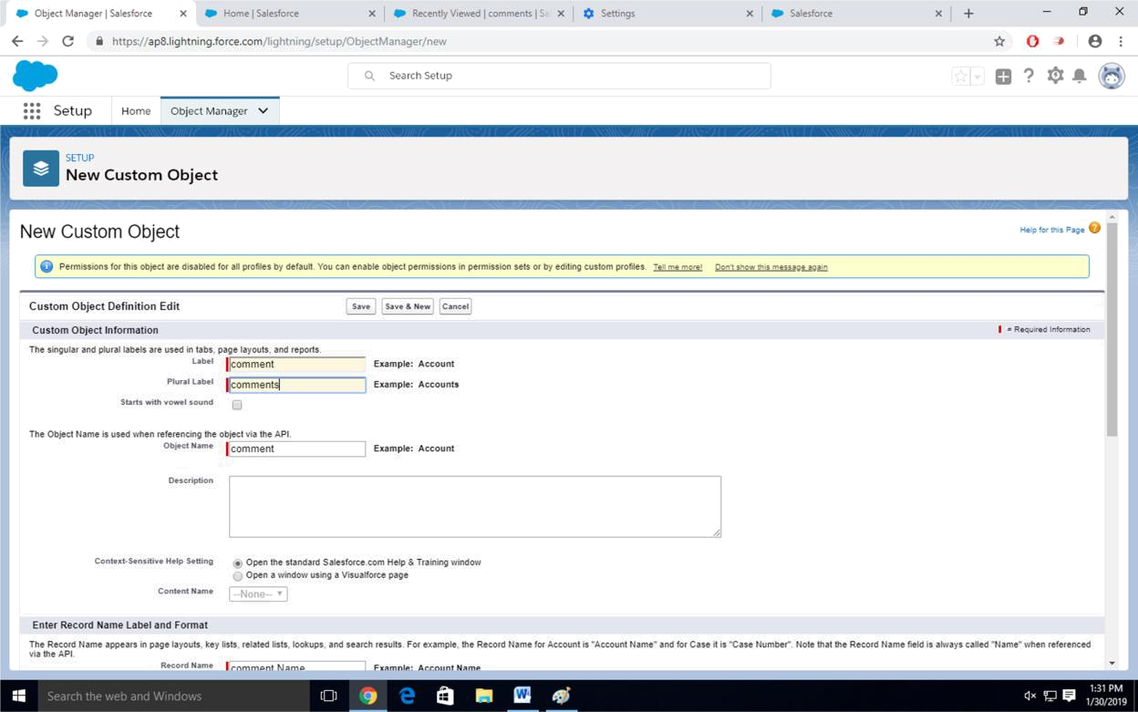

Give Record Name as –comment name

Data type- text

Select Allow Reports Check Box

Click on Save
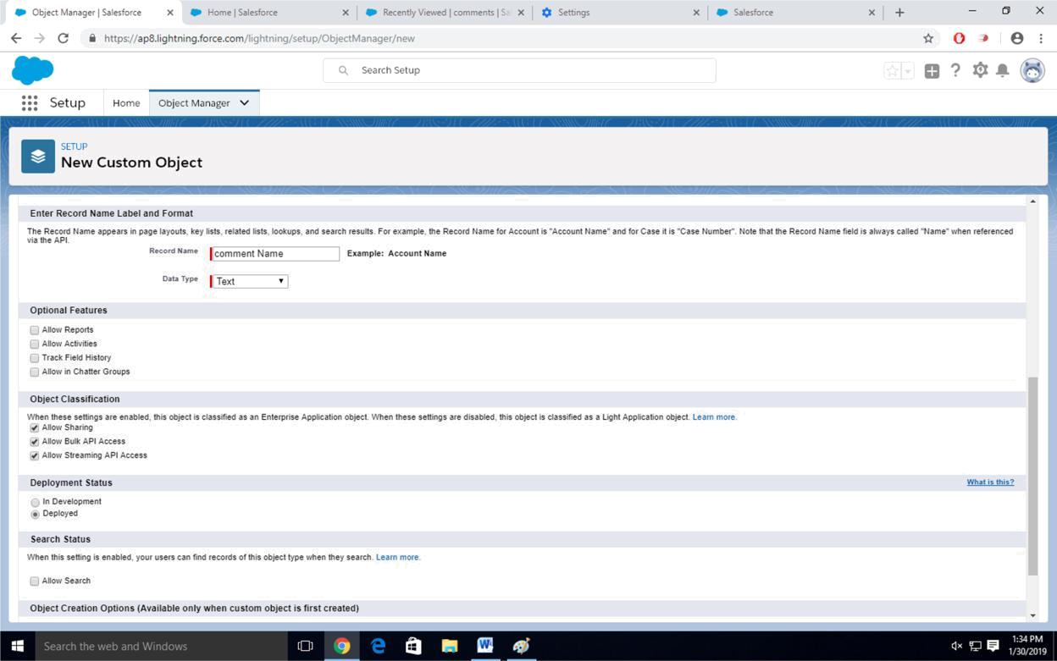

Step-5

Click on Home-Search Tabs in Quick search Select Custom Object-Click on New
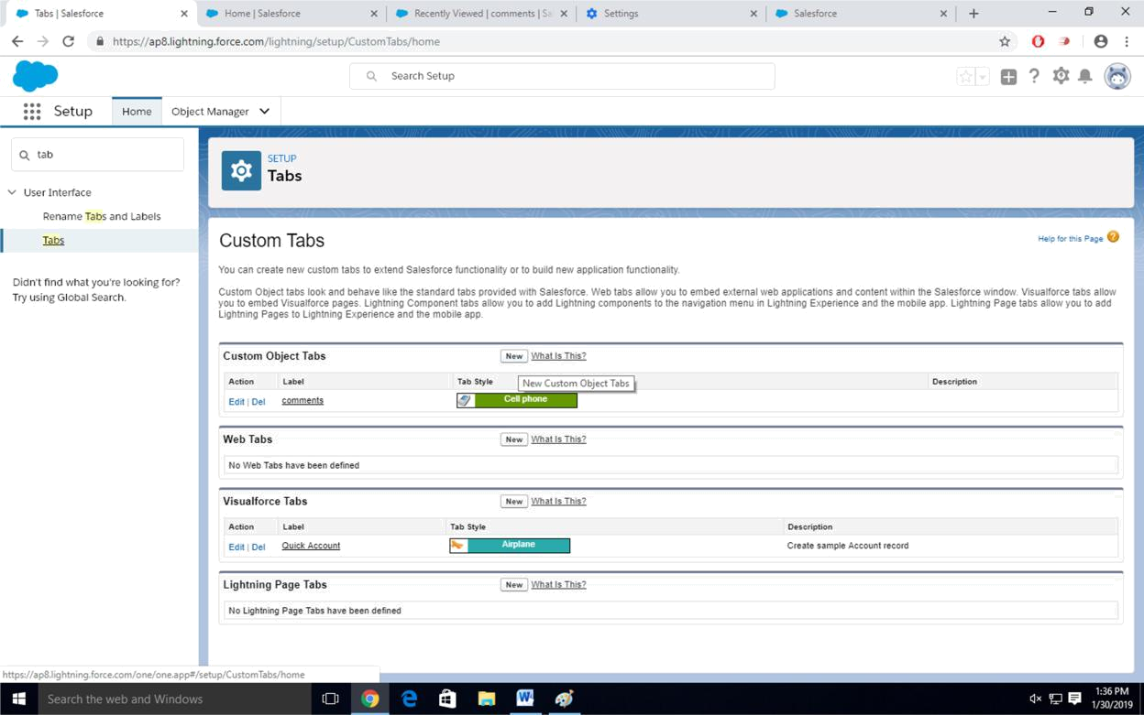

Step-6

For Object Select Comment

For Tab Style Select Any Icon
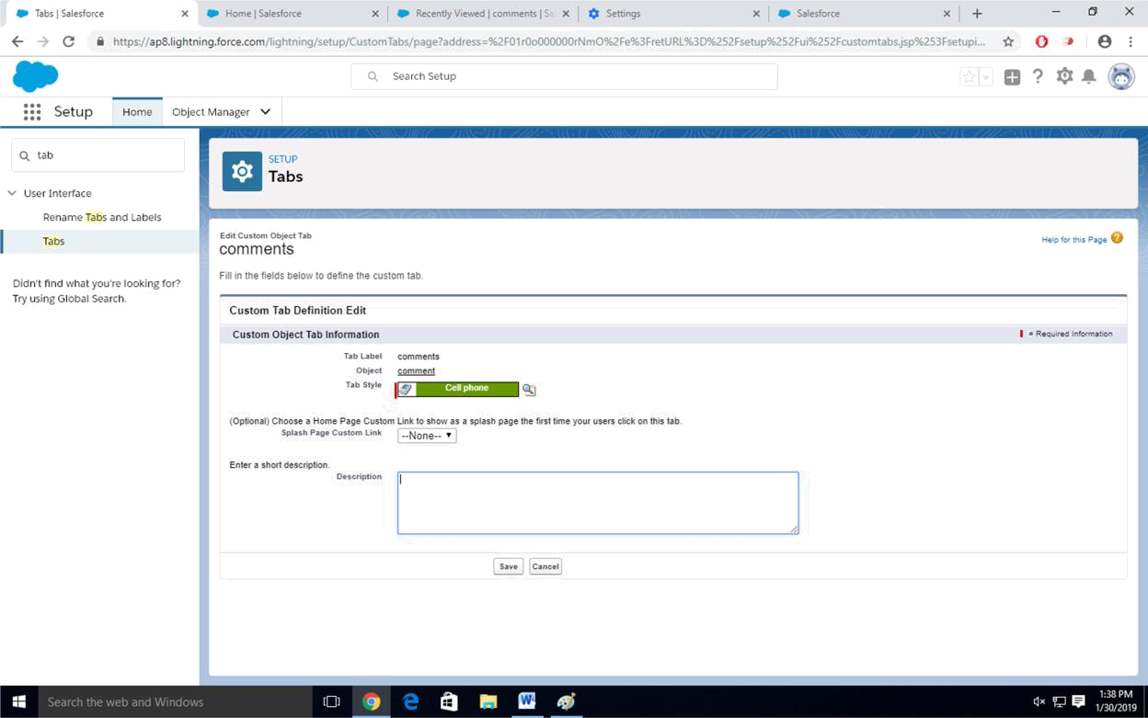

Click-Next-Next-Save

Step-7

Search App Manager in Quick Search and select app manager
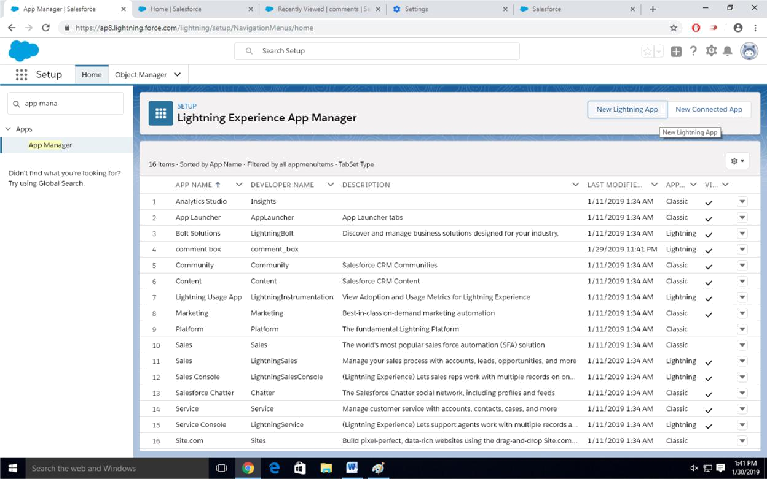

Enter name to app name
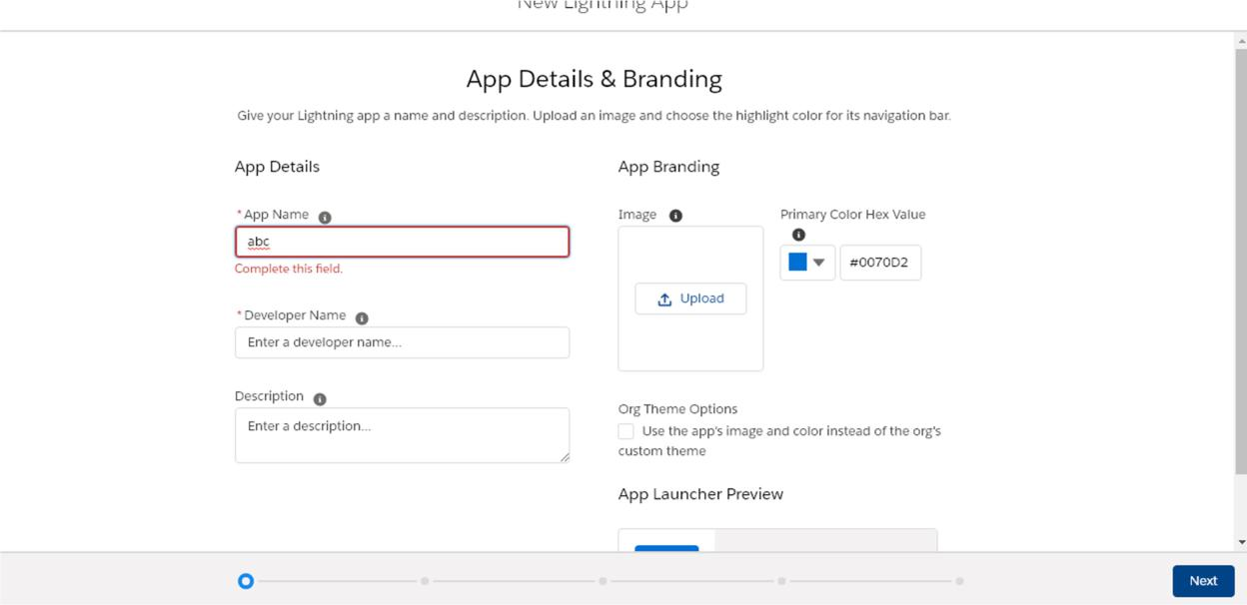

Click on Next-Next-Next.
Select Items (Contacts,Comment)

Click on Next
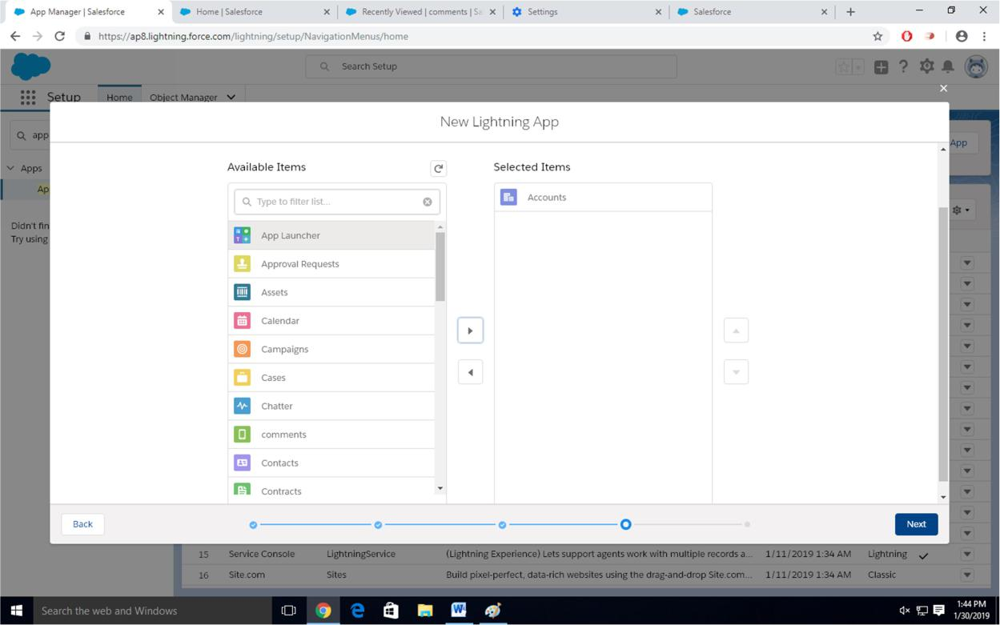

Step-8

Select Profiles ( System Administrator) and move to selected profile.

Click on Save and Finish.
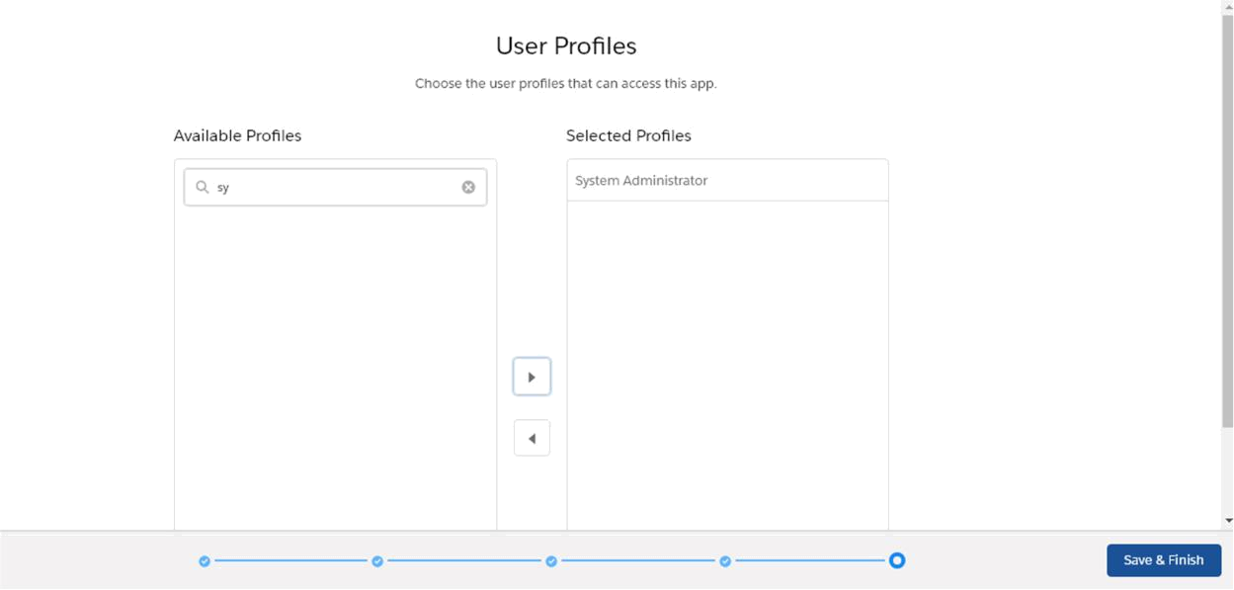

Step-9

Click on App Launcher  Symbol and Select Comment Box App
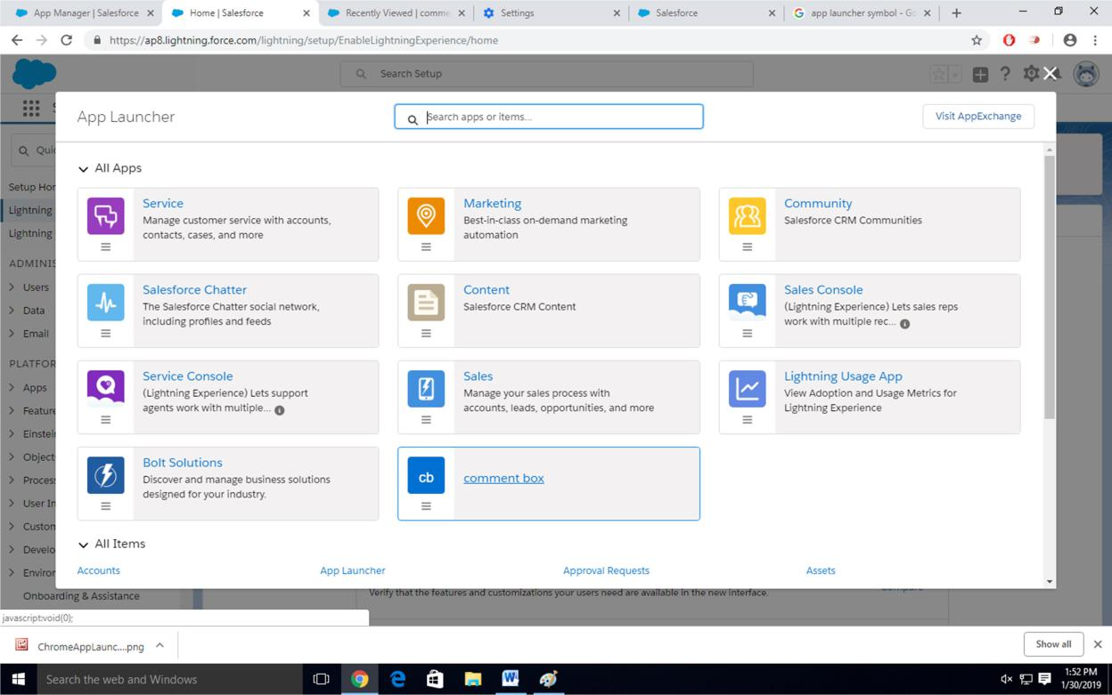
Step-11

Tour the app
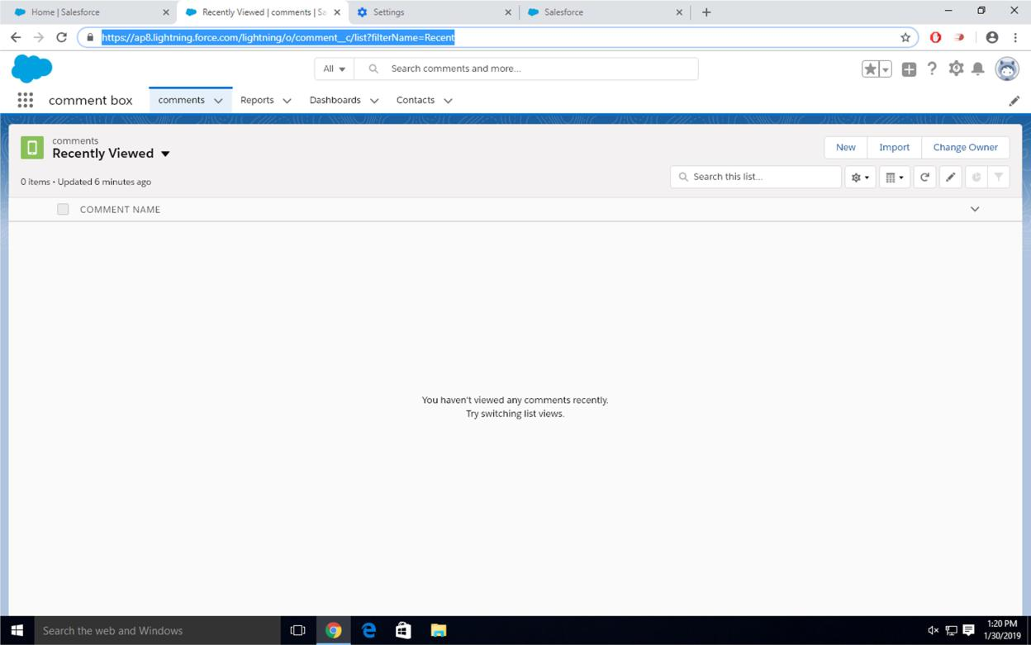

Step-12

Try out mobile app

-Select Chrome developer tools

-Open Chrome-Right Click on Chrome page- Select Inspect

-Click Toggle Device Mode Button to simulate your browser as a mobile device
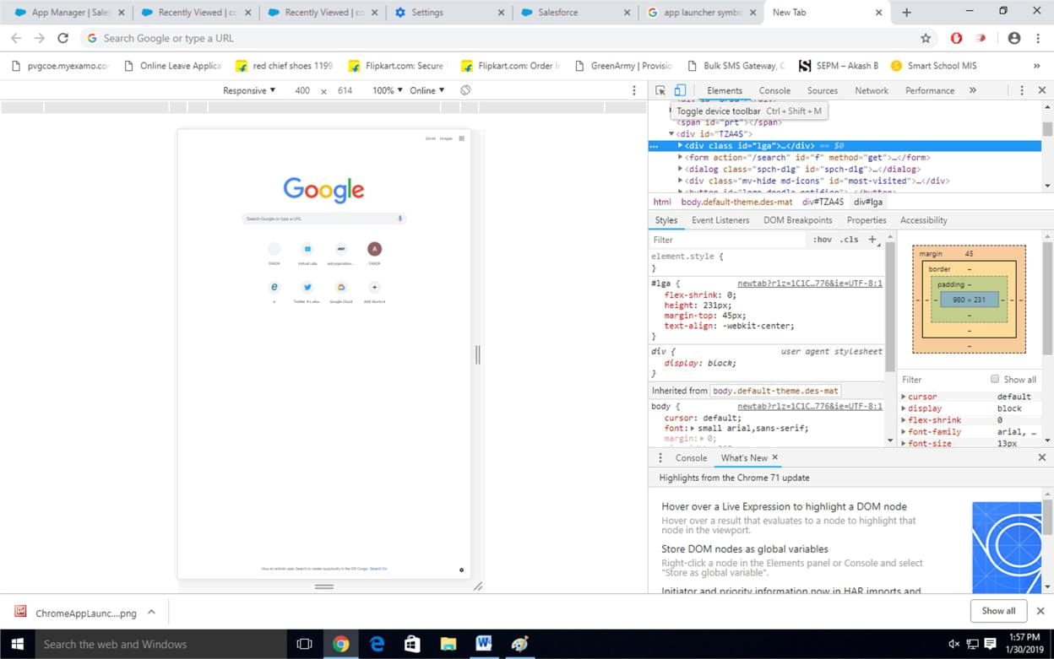

Step-13

To simulate the sales force mobile app in your browser, copy and paste in url from previous tab.Delete the part of the url immediately.

-Click on Left navigation bar

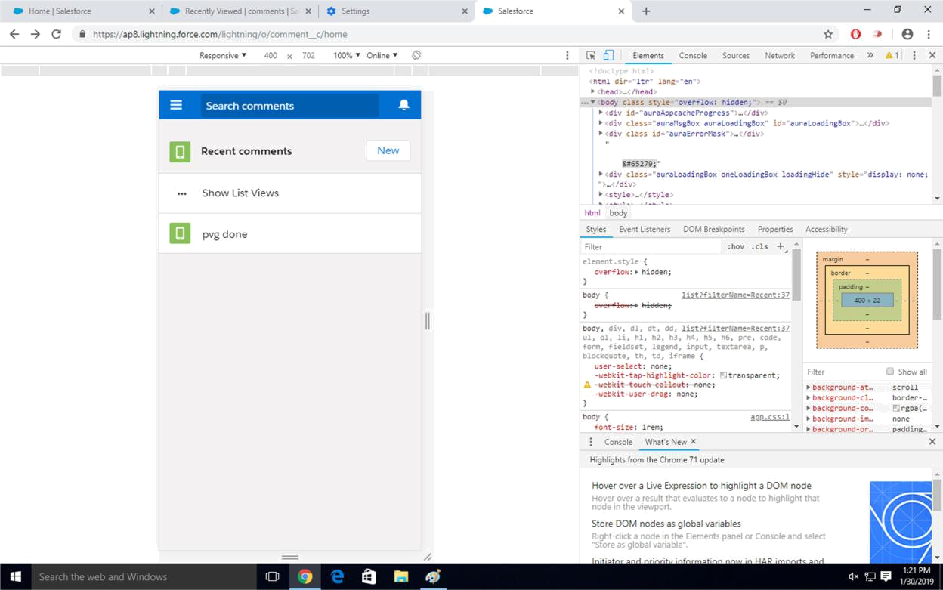
-Find comment object under recent and click on it -Click new to create a comment

